**Project**

**Silda Foods Administrative System**

***By***

**Nabeel Ahmad (FA20-BSE-170)**

**Nabeel Javeed (FA20-BSE-061)**

**Fahad Farman (FA20-BSE-044)**

**Ali Sher Khan (FA20-BSE-078)**

**Yasin (FA20-BSE-172)**

**Hassan Bin Abid (FA20-BSE-080)**

**Ahmed Hussain (FA20-BSE-067)**

***Supervisor***

**Sir Mukhtiar Azmin**

***Object Oriented Software Engineering***

**Submitted on: April 24, 2022**

***The candidate confirms that the work submitted is their own and appropriate credit has been given where reference has been made to the work of others****.*

**Department of Computer Science**

**COMSATS University Islamabad**

**Abbottabad Campus**

Table of Contents

CHAPTER 1 PROJECT PROPOSAL 4

Introduction 4

Vision and Business Case 4

Supplementary Specification 4

Risk List & Risk Management Plan 5

CHAPTER 2 USE CASES 6

Use Case Diagram 6

Brief Level Use Cases 7

Nabeel Ahmad (FA20-BSE-170) 7

Ali Sher Khan (FA20-BSE-078) 7

Ali Sher Khan (FA20-BSE-078) 7

Nabeel Javeed (FA20-BSE-061) 8

Ahmed Hussain (FA20-BSE-067) 8

Hassaan-Bin-Abid (FA20-BSE-080) 9

**Fully Dressed Use Cases** 10

Ali Sher Khan(FA20-BSE-078) 10

Ali Sher Khan (FA20-BSE-078) 12

FAHAD FARMAN (FA20-BSE-044) 24

NABEEL AHMAD(FA20-BSE-170) 31

AHMAD HUSSAIN (FA20-BSE-067) 31

# CHAPTER 1 PROJECT PROPOSAL

## Introduction

Silda Foods Administrative System is a mobile and web-based application that will automate all the administrative activities of the company and provide the company with a user-friendly management system. The system will be overseeing all the management systems required for smooth and effortless working. It will allow the administration to get rid of the old methods of business administration and adopt the modern automated management system for daily but fundamental tasks which will, in turn, grow the company financially.

## Vision and Business Case

* Supply management

• Labor management

• Salary management

• Finance management

• Account management

• Managing purchases

• Built-in inventory management system

• Managing sales

• Transport management and tracking

• Client detailed storage and management

## Supplementary Specification

***Speed*:**

Some supplementary specifications of the system are mentioned below

The system designed is equipped with the latest software so that the processing time is kept to the minimum. The system is also capable of taking on huge workload without any lag and also equipped with top-notch features which allows it to manage many tasks at once.

***Security*:**

Due to all the security features included in the package the system is deemed unbreakable, the security features include account creation, password generation etc so that only authorized personnel can access the system.

***Portability*:**

Portability is a main feature of the system as it can be accessed through any medium i.e windows, mac etc. it is compatible with any software device with certain specifications.

***Storage*:**

For capacity the system offers two options either all items and stuff is stored in the user provided storage or it is stored in the system provided capacity. Either way in both cases the system’s output will be maximum.

## Risk List & Risk Management Plan

### Risk List:

* Untrained employee

• System failure

• System override

• Less manpower for a project

• Hardware failure

• Sudden employee shortage

• System not compatible

### Risk Management Plan:

For any type of risks mentioned above, there will be a well-trained risk management team always on-call and ready to smooth out any discrepancies which may come along the way

A three-month update will make sure that the system is equipped to the right hardware and it will also remove any harmful bugs that may become a speed bump in the process.

# CHAPTER 2 USE CASES

## Use Case Diagram

## Brief Level Use Cases

### Student 1: Nabeel Ahmad (FA20-BSE-170)

Use Case: **View Driver Details**

User will make request to system to fetch driver’s details. The System will show list of drivers and ask the user to select specific driver to see its details. Also user can add new driver to the list i

Use Case: **Enter Loading Unloading Details**

Transport Manager (Primary Actor) access the system through specified credentials, after aquirng access, system provide him transport site where he make check over vehicles, loading labor and drivers availability, departure and arrival of specific vehicle including it’s timing, date, destination. After wards he updates the ongoing vehicle activities and status of vehicles with time and the system have updated information about vehicles.

Use Case: **Save & View Maintenance Report**

User start session on system and access the interface of transportation’s maintenance area, then he views the maintenance details of vehicles and save or update any new details if required.

### Ali Sher Khan (FA20-BSE-078)

**Use Case: Enter and View Sales Revenue.**

The user will make a request to the system to view the status of the sales. The system will fetch the sales data from the database and will show it to the user. The user will also be able to print the report of sales by providing the timespan for which the information is desired.

**Use Case: View Production Cost:**

The user will make a request to the system to view the cost of the production. The system will fetch the sales data from the database and will show it to the user.

**Use Case: View Maintenance Cost:**

The user will make a request to the system to view the cost on the maintenance. The system will fetch the sales data from the database and will show it to the user.

**Use Case: View Transport Cost:**

The user will make a request to the system to view the cost on transportation of the products. The system will fetch the sales data from the database and will show it to the user.

**Use Case: View and update Financial Status:**

The user will make a request to the system to view the previous final report and will be able to make a new final status report on all the costs and then the user will be able to generate the final report for the specific time span.

### Nabeel Javeed (FA20-BSE-061)

#### **Use Case: Check & Update Raw Material**

In Select supplier use case we will select the supplier including his sale information and will place the order according to our requirements (Chemical, bottle etc.) and then the order will be tracked until it arrives.

#### **Use Case: Make Invoice and Payment;**

After receiving the order, the supplier will create the order invoice that contains the total expense of the purchase made and then the payment will be made according to the invoice.

### **Yasin (FA20-BSE-170)**

Use Case: **Production Management**

**Production Management:**

This is a scientific process that involves the transformation of raw material(input) into desired product or service(output) by adding economic value. The production manager is responsible for Update Daily Production, View Machinery Timing (Start and End Time), and View Production Details for providing the main production report to the Project Manager or Supervisor according to that software app.

### Ahmed Hussain (FA20-BSE-067)

Use Case: **View Inventory Items:**

The primary actor in this use case is the purchase department. In this use case a user from the purchase dept. will be able to login to the system to view the inventory level of the items and short list the items with insufficient level and then search for suppliers to further proceed all the data will be stored automatically in the database and can be show in the history tab in the menu bar.

Use Case: **View Suppliers:**

In this use case user from the purchase department view the suppliers and according to the need he short list the suppliers for the orders to place order. The order can be automatically generated by the system as per the requirements of the inventory and then it further proceeded.

Use Case: **Online Payment:**

In this use the user open the make payment section to pay the payment to the supplier which is necessary for the delivery of product and the all the system transfer to the production department and they start the production with the raw materials.

### Hassaan-Bin-Abid (FA20-BSE-080)

#### **Use Case: Raw Material Testing**

In Raw material testing a laboratory in charge makes sure that the POS system is efficiently testing all raw material before the production process begins. In this testing mainly the fruit pulp, the plastic bottles and the chemicals are tested for any defects.

#### **Use Case: Production Testing**

In the production testing phase the lab in charge will supervise all the necessary processes required for efficient flow of the task. In production testing, the testing process is divided in three phases sample, packing and pre-packing testing.

## **Fully Dressed Use Cases**

### Ali Sher Khan(FA20-BSE-078)

| Use Case UC1: Labor Division |
| --- |

**Scope: Labor Management**

**Primary actor: HR Manager.**

**Stakeholders and Interests:**

Company: The Company wants all the details of the labors to be recorded in a digital form in the database of the Silda Food Administrative System.

HR Manager: The Manager wants to know the detailed schedule of the labor and the attendance. It will all be recorded in the software and all the details will be made available to the manager whenever desired.

**Pre-Conditions:** Manager is identified and authenticated to be able to use the system.

**Success Guarantee:** The attendance of the labor will be marked at any point where they enter the factory and this attendance will be saved. In case of any mishap the manager will know which labor was present where. The records of mishaps will be saved and the software will be able to reschedule an event if any labor is injured or any other factor. At the end of the day a report of the labor will be generated which will include their working hours for the day and their progress and will also provide the schedule for the next day.

**Main Success Scenario:**

1. The labors arrive at the factory and use the fingerprint scanner to mark their attendance.
2. The software records their attendance.
3. The labors go to their respective places and use the fingerprint scanner there to mark their attendance which is recorded by the software.
4. The manager will use his specific login in password to login into the software.
5. The manager will be able to view the attendance of the labors and the specific area and how many labors are working in that area.
6. The software will show how much labor is free and how much labor is working.
7. In case if a labor is injured or any other act of God occurs the manager will take them to hospital or grant them leave which will be recorded by the software and then used to reschedule the event or use the free labor and allot them the work.
8. In case if there is something short, the labor will make a request in the software which will be approved by HR manager.
9. The software will check the inventory and if the item is available, it will tell the manager that the product is available and can be collected from the respected place.

**Extensions:**

All the data will be saved in the database and a backup of the data will be created simultaneously so that if the system crashes the data should not be lost and the process should resume from the state it was left and not restart whole again.

**Special Requirements:**

* Lenovo monitors with ultra HD display.
* 2 Lenovo i7 10th Gen PC’s.
* Two keyboards and mousses.
* Big Generators in case the power goes out or there is a fault in the power system.

### Ali Sher Khan (FA20-BSE-078)

| UseCaseUC2:FinanceManagement |
| --- |

**Scope:** Finance Management

**Primary actor:** Finance Manager

**Stakeholders and Interests:**

The Company will keep all the financial records in the database of the Silda Foods Administrative System and will be able to generate a report more likely a statement of financial position to the owner.

The finance manager will be able to calculate the profit and loss situation of the company as well as the expenses carried out in the different processes during the purchase of raw material to the final transportation of the goods as well as the expenses on the goods that returned or were damaged during the production, loading and transportation.

**Pre-Conditions:**

The accounts officer and the owner will have the access to the finance department, and they will be provided with a special id and a password to get access to the department.

**Success Guarantee:**

The software will record all the activities that are financial in its database and will calculate the final results. The finance manager will not have the permission to make alterations in the details and will only be accountable for the calculation of the expenses and the tax.

The software will be generating a report at the end of the day to make sure that everything is kept in the right position and all the records are safe from any alterations.

**Main Success Scenario:**

* All the details of the total capital, investments and the liabilities will be stored in the database.
* The expenses on the purchase will be deducted from the capital.
* The records of paid liabilities and unpaid will be stored and only the owner will have access to alter it.
* The details on the purchases will be stored in the database.
* The total amount of sales and returned products will be stored in the database.
* The software will calculate the salaries of the employees and the salaries will be deducted from the capital.
* After all this the software will be able to calculate the profit or loss using a dedicated formula that will be used to do the calculation which will be 100% precise as the data is entered in the software.

**Extensions:**

All the data will be saved in the database and a backup of the data will be created simultaneously so that if the system crashes the data should not be lost and the process should resume from the state it was left and not restart whole again.

**Special Requirements:**

* Lenovo monitors with ultra HD display.
* 2 Lenovo i7 10th Gen PC’s.
* Two keyboards and mousses.
* Big Generators in case the power goes out or there is a fault in the power system.

**Screen Shots:**

**(2)**

### **Student 2: Nabeel Ahmad (FA20-BSE-170)**

#### **Use Case: View Drivers Details**

**Scope**: Transport Management

**Level**: User

**Primary** **Actor**: Transport Manager

**Stakeholders and Interests:**

**Company:**

Company wants to keep the updated record of its transportation, also keep in record the details of their transport of previous transportation so that it should know if any unexpected event ever occurred in case of any problems in future.

**Transport Manager:**

TransportManager wants to have digitalized system for his transportation site where he could manage his work easily and avoid any miss detailing and have updated information about loading unloading labor etc.

**Main Success Scenario:**

1. User accesses the system through his provided credentials and enters the transportation site of system.
2. User then request the system to display the loading unloading transportation details.
3. System displays details of labor, time, and vehicle which is loaded or unloaded.
4. The user then removes ambiguity in detail if any and updates the details.

**Alternate Flow:**

**Pre-Conditions:**

The user is authorized before accessing the dashboard and he wants to view or update the details of the transportation site.

**Post-Conditions:**

The user interacted with the system and provided the user with his required information and facilitated him to make updates if any, the user has made updates and viewed the details.

**Special Requirements:**

**Tech and Data Variations:**

**User Interface:**

#### **Use Case:** **Save and Update Loading Unloading Details**

**Scope**: Transport Management

**Level**: User

**Primary** **Actor**: Transport Manager

**Stakeholders and Interests:**

**Company:**

Company wants to keep the updated record of its transportation, also keep in record the details of their transport of previous transportation so that it should know if any unexpected event ever occurred in case of any problems in future.

**Transport Manager:**

TransportManager wants to have digitalized system for his transportation site where he could manage his work easily and avoid any miss detailing and have updated information about loading unloading labor etc.

**Main Success Scenario:**

1. User accesses the system through his provided credentials and enters the transportation site of system.
2. User then request the system to display the loading unloading transportation details.
3. System displays details of labor, time, and vehicle which is loaded or unloaded.
4. The user then removes ambiguity in detail if any and updates the details.

**Alternate Flow:**

**Pre-Conditions:**

The user is authorized before accessing the dashboard and he wants to view or update the details of the transportation site.

**Post-Conditions:**

The user interacted with the system and provided the user with his required information and facilitated him to make updates if any, the user has made updates and viewed the details.

**Special Requirements:**

**Tech and Data Variations:**

#### **Use Case:** **Loading Unloading Details**

**Scope**: Transport Management

**Level**: User

**Primary** **Actor**: Transport Manager

**Stakeholders and Interests:**

**Company:**

Company wants to keep the updated record of its drivers and vehicles, so that it should have the details of its vehicles and drivers and could manage its working on daily bases.

**Transport Manager:**

TransportManager wants to have digitalized system for his transportation site where he could manage his drivers and vehicles and have updated details of vehicles and drivers in order to work easily and avoid any miss detailing and have updated information about vehicles, and drivers.

**Main Success Scenario:**

**Alternate Flow:**

**Pre-Conditions:**

**Post-Conditions:**

**Special Requirements:**

**Tech and Data Variations:**

**Student No 3:**

**Hassaan-Bin-Abid(FA20-BSE_080)**

**Scope: Testing raw materials**

**Primary actor: Lab technician**

**Stakeholders and Interests:**

Lab technician: The lab technician’s job is to overlook all the necessary steps to give the end product on time and without any defects in the final product

Company: The company wants the technician to keep the end product to the company’s quality standards

**Pre-Conditions:** The lab technician is identified and authenticated to be able to use the system.

**Success Guarantee:** The product comes out without any defects or impurities that may degrade the quality

**Main Success Scenario:**

* The raw material comes in the lab without any damage
* All materials are tested separately
* The tests are done successfully
* The end product is loaded and sent for further testing
* A testing report is made to be sent to the company

**Special Requirements:**

* samsung monitors with ultra HD display.
* 2 hp i7 10th Gen PC’s.
* Two keyboards and mousses.
* Big Generators in case the power goes out or there is a fault in the power system.

| Use Case UC2: Production Testing |
| --- |

**Scope: Testing final Product**

**Primary actor: Lab Technician.**

**Stakeholders and Interests:**

The Company wants to make sure that the end product is free of any defects and it meets the company’s quality standards

Lab technician is there to make sure that all the tests are performed smoothly and without any discrepancies so that the end product is perfect

**Success Guarantee:**

All the testing stages are done smoothly and swiftly and the end product is without any defects.

**Main Success Scenario:**

* All the elements for testing come safe and sound
* All elements are separated for individual testing
* The sample is tested before packing
* The packing is tested afterwards
* A final report is made to be sent to the company

**Special Requirements:**

* samsung monitors with ultra HD display.
* 2 dell i7 10th Gen PC’s.
* Two keyboards and mousses.
* Big Generators in case the power goes out or there is a fault in the power system.

**Screen Shots:**

### **Student 3: Nabeel Javeed (FA20-BSE-061)**

**Use case:** Check & Update Raw Material

**Scope**: Maintaining Raw material

**Level**: User

**Primary** **Actor**: Purchaser

**Stakeholders and Interests**:

Raw Material Manager maintain the inventory. Managers use this scenarios to update the new Raw material records

Company wants to accurately record transactions and satisfy customer interests. Wants to ensure that Payment Authorization Service payment receivables are recorded. Wants some fault tolerance to allow sales capture even if server components (e.g., remote credit validation) are unavailable. Wants automatic and fast update of accounting and inventory.

**Preconditions**: Purchaser is identified and authenticated.

**Success Grantee:** In this Software the purchaser process maintain easily. and the CEO easily look everything in any time. And Less amount of chance to mistake in this system.

**Success Scenario:**

* In this software purchaser performed several works in less time.
* Purchasers add the requirement in the software and software determine the supplier.
* When purchaser determine supplier then they placed order in short time.
* Suppliers take order and respond on it.

**Use case:** Enter Order

**Scope**: Order Management

**Level**: User

**Primary** **Actor**: Purchaser

**Stakeholders and Interests**:

-Purchaser: Want to placed order according to needs. and mention the details about order likes its quantity, Company Names etc.

Supplier: It takes the order and Respond on it. If all the require Entities are available then the accept order. And make a invoice.

- Company: Wants to accurately record transactions and satisfy customer interests. Wants to ensure that Payment Authorization Service payment receivables are recorded. Wants some fault tolerance to allow sales capture even if server components (e.g., remote credit validation) are unavailable. Wants automatic and fast update of accounting and inventory.

**Preconditions**: Purchaser is identified and authenticated.

**Success Grantee:** In this Software the purchasing process maintain easily. and the CEO easily look everything in any time. And Less amount of chance to mistake in this system.

**Success Scenario:**

* Purchaser placed order through software in short time.
* In the help of software purchaser easily search the supplier.
* System give more information to purchaser like product name etc.

**Special Requirements:**

• Lenovo monitors with ultra HD display.

• 2 Lenovo i7 10th Gen PC’s.

• Two keyboards and mousses.

• Big Generators in case the power goes out or there is a fault in the power system.

**Use Case**: Make payment

**Level**: User

**Primary** **Actor**: Purchaser

**Stakeholders and Interests**:

Raw material manager: Raw material manager make invoice about order. And send to the account office to verifications. After verification Account officer pay the invoice amount through online or baking system.

- Payment Authorization Service: Wants to receive digital authorization requests in the correct format and protocol. Wants to accurately account for their payables to the store.

Finance Manager: After verification the officer pay the payment to supplier account through Baking or online payment

- Company: Wants to accurately record transactions and satisfy customer interests. Wants to ensure that Payment Authorization Service payment receivables are recorded.

**Success Grantee:** In this Software the payment process maintain easily. and the CEO easily look everything in any time. And Less amount of chance to mistake in this system.

**Success Scenario:**

* System should make digital invoice about the order.
* Manager should verify the invoice through portal in short time.
* After verification System transfer invoice to Finance department.
* Finance Officer pay the payment through online payment system in short time.

**Special Requirements:**

• Lenovo monitors with ultra HD display.

• 2 Lenovo i7 10th Gen PC’s.

• Two keyboards and mousses.

• Big Generators in case the power goes out or there is a fault in the power system.

### FAHAD FARMAN (FA20-BSE-044)

#### Use Case: Check availability of product

In the checking of availability of product the sales manager check the product which are available in the stock and will place order according to the requirement and then generate a report on the stock which is available

Use Case: View sales details

After checking the available stock sales manager check the sales details .Check the sales of the product

and generates a report on the sales

Use Case: prepare order recipt:

After checking sales sale dealer prepare order recipt .Also check the order details .Sales dealer prepare order for the customer .Sales dealer fulfill the need of the client

Use Case: provide order details :

After prepare order paid the purchase employees will go over the order details whether the quantity and quality and all other requirement components of the order are according to the order placed .Also give the details to the client either order is accepted or order is rejected or order is rejected .

order for the customer .Sales dealer fulfill the need of the client

Use Case: save order and client details :

After order details sale dealer save order details order quality quantity and other requirement and also save the details of the client ,client name client id and other necessary requirement.

**Actors of our project:**

**Primary Actor:**

Some are the primary actors of our project which are given below:

* sale manager
* sale dealer

**Secondary Actor:**

Secondary actor of our project is

* production manger

**Use cases:**

Some are the use cases of our project which are given below:

* Login
* Signup
* check availabilty of product
* view sale detail
* prepare order rececipt
* provide order detail
* save order & client deatil

**Fully dressed use cases:**

fully dressed use cases are as follows

**Fully dressed Use Case for check availability product**

|  |  |
| --- | --- |
| Use case Name | Check availability product |
| Scope  Level | To facilitate sale manager |
| Primary Actor | Sale manger |
| Stakeholders and Interest | Sale manager , production dealer, production manager |
| Main success Scenario | * Login to system * System will prompt the manger * After verifying the user system will prompt the sale menu * Sale manager will open Check production list |
| Alternate Flow | **A:** **Verify prodution details**   * Sale manger will check the available product * System will generate report * System will ask for available product report report * sale manger will select the option * System will send the verification code * Sale manager will enter the verification code * System will verify the verification code   **B:** **Failure in the system**   * System will ask to restart the application * If still not working * System will ask the user to update the application |
| Pre-Condition | * Sale manager must Register to the system * Sale manager must be login to the system |
| Post-Condition | * Give Feedback * Certificate of experience * Logout from the system |
| Special Requirement’s | * System should response within seconds * Easy to use * System should secure the data of all user’s * Data should be saved for one year |
| Technology and data variations list | * Manager can login though finger print * Manger will login through PIN |

**Fully dressed Use Case for Contact view sale details**

|  |  |
| --- | --- |
| Use case Name | View sale detail |
| Primary Actor | Sale manger , sale dealer, |
| Scope | To check the details of sale |
| Stockholder and Interest | Sale manger , sale dealer, product manger |
| Main success Scenario | * Login to system * System will prompt the manger * After verifying the user system will prompt the sale Menu * manger will open Check sales details * After watching the sales detail list manger will start future panning |
| Alternate Flow | **A:**   * If the manager wants to check the sale details * System will generate sale details report * System will ask for option of verification i-e verify through Email or phone no. * User will select the option * System will send the verification code * After the verification sales details report generate   **C:** **Failure in the system**   * System will ask to restart the application * If still not working * System will ask the user to update the application |
| Pre-Condition | * sale manager must Register to the system * Manger must be login to the system |
| Post-Condition | * Give Feedback * Logout from the system |
| Special Requirement’s | * System should response within seconds * Easy to use * System should secure the data * Data should be saved for one year |

|  |  |
| --- | --- |
| Use Case | signup |
| Actor | Sale manager |
| Type | Primary |
| Description | 1. User will enter username and password 2. System will verify the username and password. After validation system will show home page 3. Account will be Successfully Verified |

|  |  |
| --- | --- |
| Use Case | Login |
| Actor | Sale manager ,sale dealer |
| Type | Primary |
| Description | 1. System Request the Actor to enter the user name and password 2. User enter the user name and password 3. The system validates the user name and password, and show Sale Menu |

|  |  |
| --- | --- |
| Use case | Provide order detail |
| Actor | Sales dealer |
| Type | Primary |
| Description | 1. Sales dealer provide the order information 2. sales dealer can update the Record 3. sales manager give details of order to client 4. Dealer check the order details accepted or not accepted |

|  |  |
| --- | --- |
| Use case | Order details and client details |
| Actor | Sales dealer |
| Type | Primary |
| Description | 1. Sales dealer provide the order information 2. sales dealer can update the Record 3. sales manager give details of order to client 4. Dealer check the order details accepted or not accepted 5. Client details is also saves |

### AHMAD HUSSAIN (FA20-BSE-067)

**Fully Dressed Use Cases:**

**Fully dressed Use Case for viewing Inventory Level**

|  |  |
| --- | --- |
| Use case Name | View Inventory Level |
| Primary Actor | Purchase Dept. |
| Scope | To view inventory level of insufficient items. |
| Stockholders | Sales Manager, Production Dept., Purchase Dept. |
| Main success Scenario | 1. Login to system.  2. User will open menu bar to View Inventory Level.  3. After viewing the inventory level User will search for suppliers. |
| Alternate Flow | **1.1**  If user is already logged in the login page does not shown to the user.  **1.2**  If information is incorrect then it returns to the login page.  **2.1**  If the user want to show the dashboard the system does not open the menu bar.  **2.2**  If user clicks to view history then the system show the history.  **3.1**  If the inventory items are enough then it does not further proceed. |
| Pre-Condition | * User are registered already. * Database has already stored the information of the users. |
| Post-Condition | * Analyze the inventory items thoroughly and search for the suppliers. * Logout from the system. |
| Special Requirement’s | * System should response within seconds. * Easy to use. * System should must be encrypted by the modern standards of encryption. * Data should be saved automatically in the history tab on the menu bar. |

**Fully dressed Use Case for viewing Inventory Level**

|  |  |
| --- | --- |
| Use case Name | View Supplier |
| Primary Actor | Purchase Dept. |
| Scope | To view suppliers for insufficient items. |
| Stockholders | Supplier, Production Dept., Purchase Dept. |
| Main success Scenario | 1. Login to system.  2. User will open menu bar to View Suppliers.  3. After viewing the Suppliers User will start generating order. |
| Alternate Flow | **1.1**  If user is already logged in the login page does not shown to the user.  **1.2**  If information is incorrect then it returns to the login page.  **2.1**  If the user want to show the dashboard the system does not open the menu bar.  **2.2**  If user clicks to view inventory level then the system shows inventory level.  **3.1**  If the user does not want to generate order then it does not further proceed. |
| Pre-Condition | * User are registered already. * Database has already stored the information of the users. |
| Post-Condition | * Analyze the Suppliers shown thoroughly and place order. * Logout from the system. |
| Special Requirement’s | * System should response within seconds. * Easy to use. * System should must be encrypted by the modern standards of encryption. * Data should be saved automatically in the history tab on the menu bar. |

**Fully dressed Use Case for viewing Inventory Level**

|  |  |
| --- | --- |
| Use case Name | Online Payment |
| Primary Actor | Purchase Dept. |
| Scope | To make payments to the suppliers for the order. |
| Stockholders | Supplier, Production Dept., Purchase Dept., Bank admin. |
| Main success Scenario | 1. Login to system.  2. User will open menu bar to make online payment.  3. After Making the payment supplier will deliver the order. |
| Alternate Flow | **1.1**  If user is already logged in the login page does not show to the user.  **1.2**  If information entered by the user is incorrect then it returns to the login page.  **2.1**  If the user want to show the dashboard the system does not open the menu bar.  **2.2**  If user clicks to view inventory level then the system shows inventory level.  **3.1**  If the user does not want to make payment then it does not further proceed. |
| Pre-Condition | * User are registered already. * Database has already stored the information of the users. |
| Post-Condition | * Supplier deliver the order. * Logout from the system. |
| Special Requirement’s | * System should response within seconds. * Easy to use. * System should must be encrypted by the modern standards of encryption. * Data should be saved automatically in the history tab on the menu bar. |

**PROJECT CONTRACTS**

**Use case: ViewInventoryItems**

**Contract 01:** View Inventory item.

**Operation:** View inventory level (Insufficient items).

**Cross reference:** Use case: ViewInventoryItems.

**Pre-condition:** There are items to show.

**Post-condition:** - the user ask for the supplier to place order.

-the system suggests the best supplier for the order of item required.

-the order has been placed by the user.

**Contract 02:** View Supplier.

**Operation:** View Supplier (Required items).

**Cross reference:** Use case: ViewInventoryItems.

**Pre-condition:** There are Suppliers for the order to place.

**Post-condition:** - the system generate the order details.

-the user place order for the items to supplier.

-the system update the status of that item.

**Contract 03:** Place Order.

**Operation:** Place Order.

**Cross reference:** Use case: ViewInventoryItems.

**Pre-condition:** The order has to be placed.

**Post-condition:** - the system verifies the order.

-the user make payment to complete the order.

-the system updates the status.

**Use case: OnlinePayment**

**Contract 01:** Payment Options.

**Operation:** View Payment Options.

**Cross reference:** Use case: OnlinePayment.

**Pre-condition:** There are different payment options.

**Post-condition:** - the system shows the options available.

-the user chooses from the given options.

-the system verifies the account selected for payment.

**Contract 02:** Make Transaction.

**Operation:** Make a transaction from given options.

**Cross reference:** Use case: OnlinePayment.

**Pre-condition:** The user has to choose a payment option to complete payment.

**Post-condition:** - the system verifies the details given by user.

-the user after the verification confirms the details.

-the transaction is done by the user.

**Contract 03:** Approve Transaction.

**Operation:** Approve transaction.

**Cross reference:** Use case: OnlinePayment.

**Pre-condition:** The user has to approve the payment through the security pin/passcode.

**Post-condition:** - the user gave approval to system to continue transaction.

-the system shows the receipt in the form of screenshot.

# CHAPTER 3 DIAGRAMS

## **Sequence Diagram**

### **Student 1: Nabeel Javeed (FA20-BSE-061)**

**Use Case :**

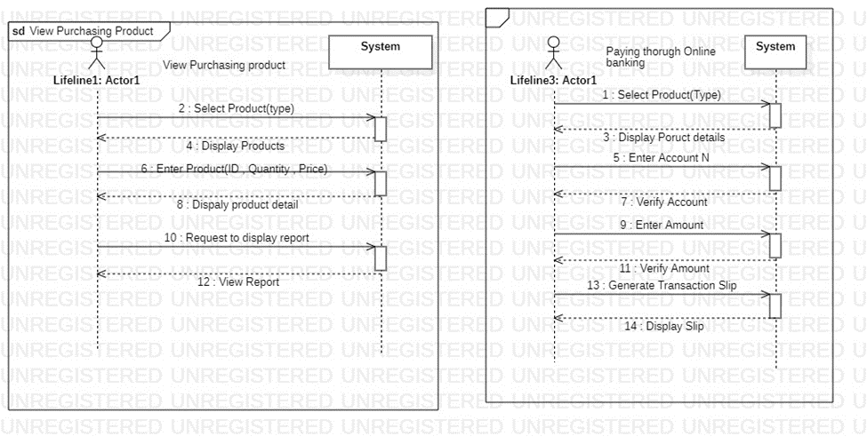

### Student 2: Nabeel Ahmad (FA20-BSE-170)

Use Case: View Drivers Details

### Student 3: Hassaan Bin Abid(FA20-BSE-080)

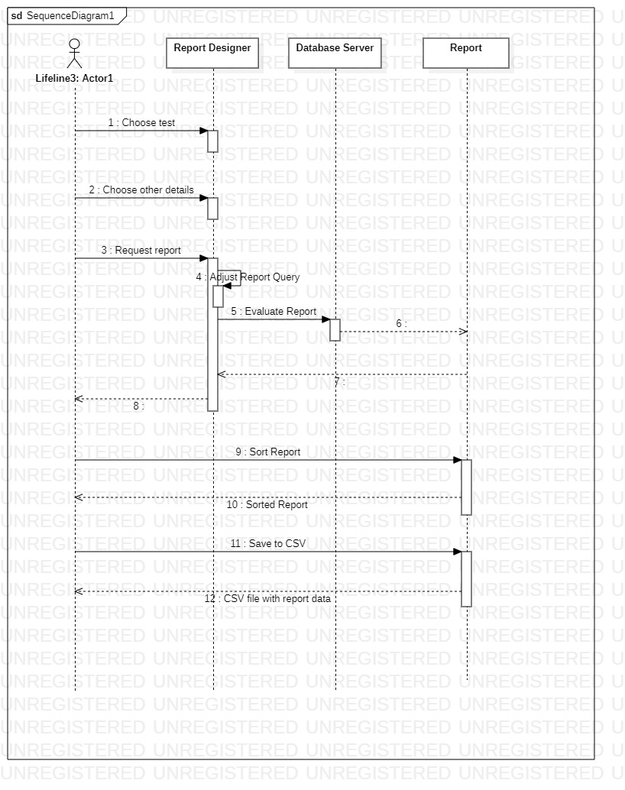

## Operational Contracts:

### Student 1 Nabeel Javeed (FA20-BSE-061)

**Operation Contracts**: 1

**Operation**: Paying through Online banking

**Cross-Reference**: select product Type

**Pre-condition**: First, we can select those products who’s these against we will send payment.

**Post-condition**: when we select those product type system display product details like quantity price etc.

**Operation**: Paying through Online banking

**Cross-Reference**: Enter Account No

**Pre-condition**: After product selection we will enter Supplier Account number and send to verification.

**Post-condition**: System verified Account No if verification true System proceed next other Show massage to user again enter correct account no

**Operation**: Paying through Online banking

**Cross-Reference**: Enter Amount

**Pre-condition** we will enter Amount and send to verification.

**Post-condition**: System verified Amount if verification true System proceed next other Show massage to user again enter correct account no

**Operation**: Paying through Online banking

**Cross-Reference**: Generate Report

**Pre-condition**: We can send command to system to generate the transaction slip

**Post-condition**: After Generate Transaction slip we will printout it

**Operation Contracts**: 2

**Operation**: Check and details Purchase product

**Cross-Reference**: Select Product (Type)

**Pre-condition**: First, we can select those products

**Post-condition**: when we select those product type system display product details like quantity price etc.

**Operation** Check and details Purchase product

**Cross-Reference**: Enter Product Details (ID , Quantity , Price , Date)

**Pre-condition**: adding product details

**Post-condition**: After adding product details display all info about product.

**Operation**: Check and details Purchase product

**Cross-Reference**: Request to display product details

**Pre-condition**: After completion adding we will send request to system to display details

**Post-condition**: After displaying we will send request for print.

### Student 2: Hassaan Bin Abid(FA20-BSE-080)

|  |
| --- |
| **Contract CO1:** **View Test report** |

|  |  |
| --- | --- |
| Operation | View Test Report (Monthly,weekly,daily) |
| Cross reference | Use Case: Generate report |
| Pre-condition | User login successfully |
| Post-condition | Report is visible to Lab technician |

|  |
| --- |
| **Contract CO1:** **Duration Enter** |

|  |  |
| --- | --- |
| Operation | Duration enter(Monthly,weekly,daily) |
| Cross reference | Use Case: Details entered |
| Pre-condition | User entered details successfully |
| Post-condition | Report is visible to lab technician |

|  |
| --- |
| **Contract CO1:** **View report** |

|  |  |
| --- | --- |
| Operation | View Report |
| Cross reference | Use Case View report |
| Pre-condition | User login successfully |
| Post-condition | View report is visible to technician |

|  |
| --- |
| **Contract CO1:** **Request for login** |

|  |  |
| --- | --- |
| Operation | Request for login |
| Cross reference | Use Case request for login |
| Pre-condition | User login successfully |
| Post-condition | Customer is successfully logged in. Database System is running. |

## System Sequence Diagram:

### Student 1 Nabeel Javeed (fA20-BSE-061)

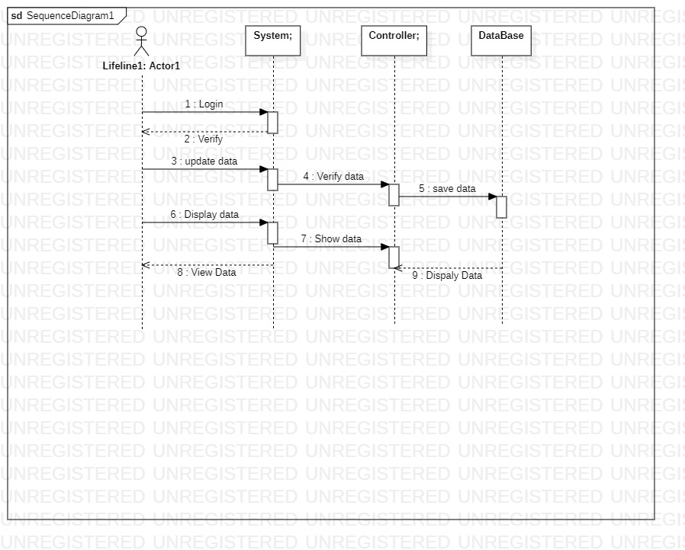

### Student 2: Nabeel Ahmad (FA20-BSE-170)

Use Case: View Drivers Details

### Student 3: Hassaan Bin Abid(FA20-BSE-080)

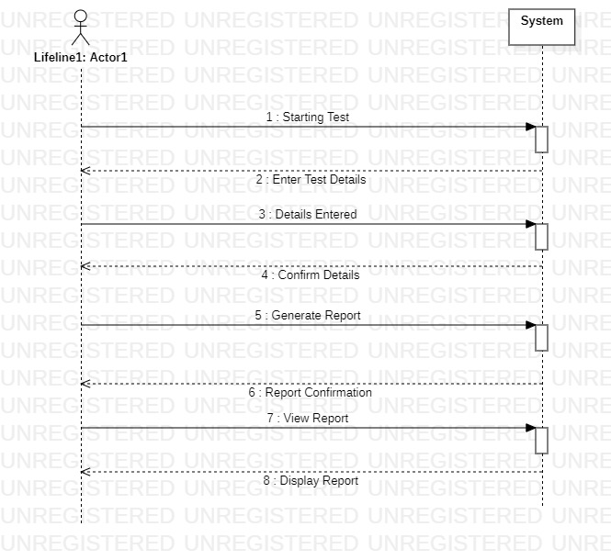

## Domain Models

### Student 1 Nabeel Javeed (fA20-BSE-061)

### Student 2: Nabeel Ahmad (FA20-BSE-170)

Use Case: View Drivers Details

### Student 3: Hassaan Bin Abid(FA20-BSE-080)

